APRIL COUNSELOR CONNECTION
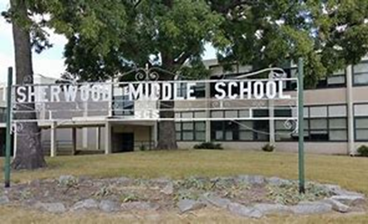
NEWS YOU CAN USE
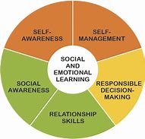  RETURN STRONGER ARCHERS  BELL TIME: 7:15 AM – 2:15 PM  As some of you return to the building, remember to come dressed in school uniforms and wear your mask.  Sherwood Archers will take part in Social and Emotional Learning (SEL) Lessons Daily  Class of 2025-Gearing up for High School Transition:  4 Year Plans  Class of 2026- Be sure to complete your Kuder Career Interest Assessment | You are a Sherwood Archer and  Sherwood Archers  Always respect self, others, and property  Initiate higher-level thinking  Make good decisions  Upcoming Events  3rd Nine Weeks Ends (15th)  Professional Development Day/Students Out (16th)  4th Nine Weeks Begins (19th)  Report Cards Issued (21st)  Administrative Professional’s Week/Day (18th-24th /21st)  Drop Everything and Read Month  School Library Month  Community Service Month
SEL COMPONENT OF THE MONTH: SELF MANAGEMENT/SELF-CONTROL
Self-Management (Self-Control): The ability to regulate one’s emotions, thoughts, and behaviors effectively in different situations. This includes managing stress, motivating oneself, and setting and working toward personal and academic goals.
BE SURE TO VISIT THE COUNSELORS OF SHERWOOD MIDDLE WEBSITE
WWW.COUNSELORSOFSHERWOODMIDDLE.WEEBLY.COM
 | RETURN STRONGER ARCHERS!!  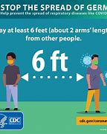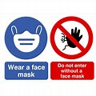 | 7TH GRADE NEWS  7TH grade students will continue taking the Kuder Career Interest Assessment. This assessment will help students match their interests with careers. College and Career planning requires learning about yourself first to ensure you choose the right career path for you based on your interests and skill set. | 8TH GRADE NEWS  8th grade students will complete their 4 Year Focused Plan of Study for High School, which will help them identify core courses, career focused electives, and early post-secondary options that are available in high school. Preparation Is Key!!
Ms. Brown (6th Grade) Ms. Hamilton (7th Grade) Ms. McGee (8th Grade)

